Ideation Phase
Empathize & Discover

Date | 01 October 2026
Team ID | SWTID-2026-2372
Project Name | Streamlining IT Procurement: Automating Standard Laptop Orders with Flow Designer
Maximum Marks | 4 Marks

Empathy Map Canvas:
An empathy map is a simple, easy-to-digest visual that captures knowledge about a user’s behaviours and attitudes.

It is a useful tool to helps teams better understand their users.
Creating an effective solution requires understanding the true problem and the person who is experiencing it. The exercise of creating the map helps participants consider things from the user’s perspective along with his or her goals and challenges.
Example:


Reference: https://www.mural.co/templates/empathy-map-canvas

Example: Food Ordering & Delivery Application
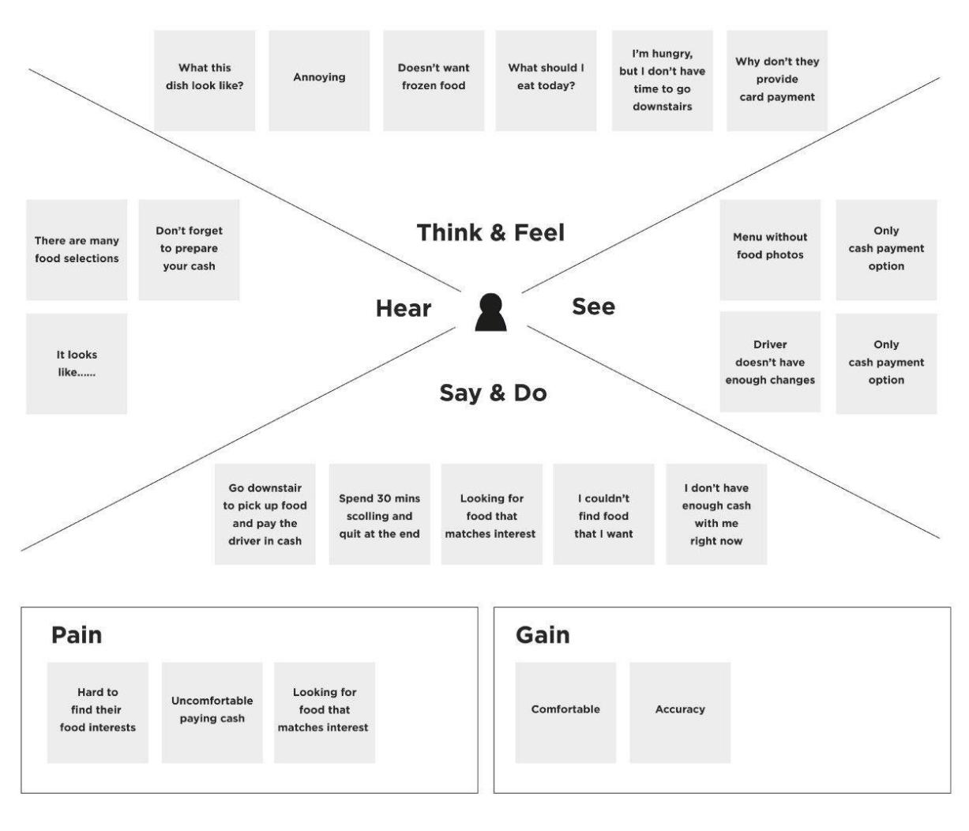

Empathy Map – Target User: Person Receiving a High-Risk Voice Call
SAYS | “How do I know this caller is really the person they claim to be?”  “I do not want to share personal or financial information with a fake voice.”
THINKS | Voice cloning can sound very realistic.  A trusted person’s voice may still be impersonated.  An authenticity warning would help before taking action.
DOES | Answers calls, listens to the caller, checks the context, and may consider sharing information or completing a requested action.
FEELS | Uncertain, cautious and concerned about scams when the request involves money, passwords, personal information or urgent decisions.
PAINS & GAINS | Pains: difficulty distinguishing genuine and AI-generated voices; fear of impersonation and financial loss.  Gains: quick authenticity feedback, early warning, simple risk status, and privacy-conscious processing.
User Goals and Challenges
• Goal: communicate confidently without being misled by AI-generated or cloned voices.
• Goal: receive an early warning before sharing sensitive information or completing a risky action.
• Challenge: AI-generated speech can be highly realistic and difficult to identify manually.
• Challenge: users need understandable detection results rather than complex technical information.
• Need: a fast, reliable and privacy-conscious voice authenticity detection approach.

